Parking Lot

The carnival parking lot stretches across an open field, its gravel crunching under arriving cars. Temporary floodlights and the carnival's colorful glow light the area, while distant laughter, music, and the hum of rides fill the air.

Cars park haphazardly, guided by makeshift signs and fluttering flags. Families unload strollers and blankets, their chatter mixing with the carnival sounds. Others linger in vehicles, preparing for the chilly evening.

Shadows from nearby trees create dark pockets pierced by the occasional flashlight. Near the entrance, an attendant collects fees at a weathered booth, coins jingling in the cash box.

Puddles from recent rain shimmer with reflected lights, while patches of mud cling to unwary shoes. At the far end, RVs and trailers sit quietly, their occupants watching the Ferris wheel spin lazily against the sky.

Alive with anticipation, the parking lot marks the transition from the ordinary to the magic of the carnival.

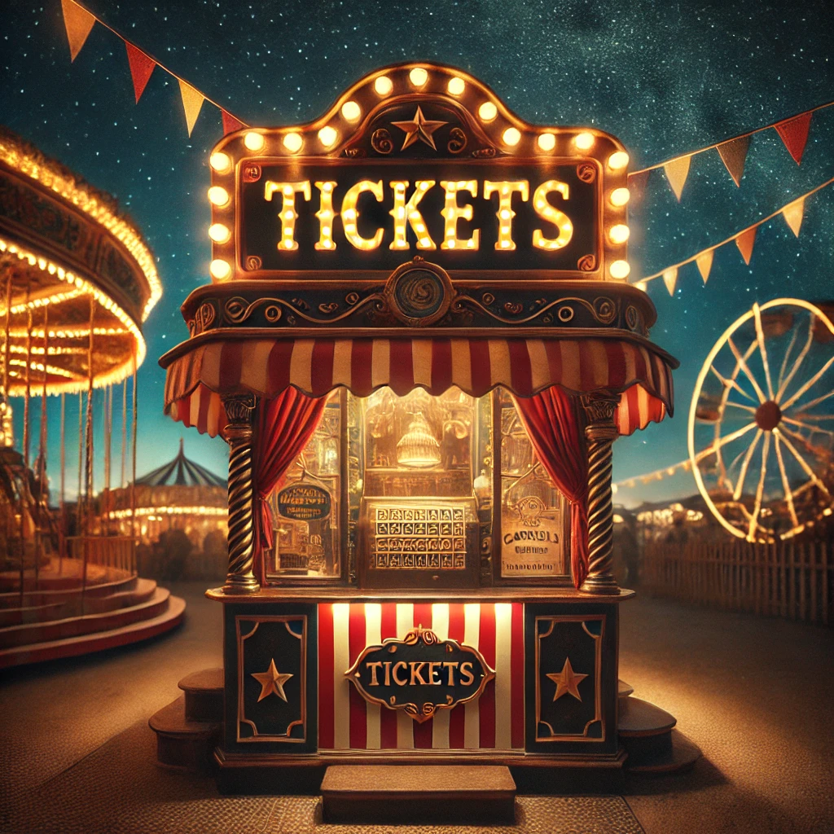

Ticket Booth

The ticket kiosk stands at the carnival entrance, a compact booth painted in bright red and yellow stripes with bold letters above the window reading "Tickets Here!" Twinkling lights outline its edges, blinking rhythmically to draw attention.

A single window serves visitors, where a smiling cashier dispenses colorful tickets from neatly arranged rolls. Beside the tickets, a cash drawer jingles as change is counted, and a digital payment system glows faintly for modern convenience. Too bad you don't have a debit card.

Next to the kiosk, a vibrant signboard lists ticket prices with playful illustrations of rides. Pennant flags flutter from the kiosk's roof, adding to the festive atmosphere, while the smell of popcorn and pretzels wafts from the southwest.

The worn ground around the kiosk shows the passage of eager carnival-goers. Families, couples, and friends form a buzzing line, their excitement building as they approach this first step into the magic of the carnival.

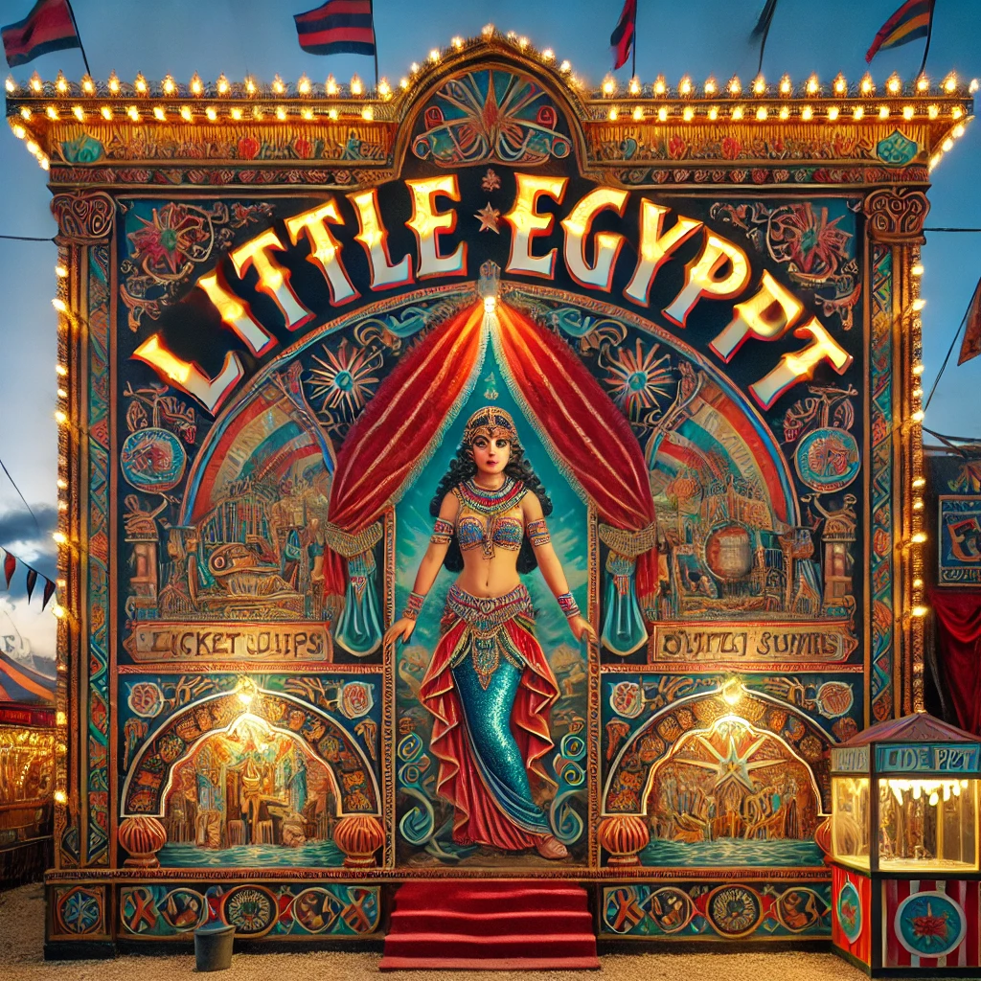

Show Facade

You head west through the midway, the bright lights of the carnival fading behind you as you approach a tent. A sign above the entrance reads "Little Egypt Show - A Journey Into the Mysterious and Exotic!" A rotund barker, wearing a fez and a dazzling smile, gestures to a small sign beside him that says "Little Egypt - Dime Admission." The Ticket Kiosk is back the way you came.

There is a stage in front of the tent. The Barker is encouraging you to step up and enjoy the Little Egypt Show.

You can see a Barker here. The barker cries:

Ladies and gentlemen, boys and girls, gather 'round!

Step right up and witness the spectacle that's taken the world by storm!

She walks, she talks, she crawls on her belly like a reptile.

Behold the one, the only Little Egypt, performing her legendary Dance of the Pyramids - a dazzling display of mystery, grace, and exotic allure!

For just a dime, a mere one tenth of a dollar, prepare to be transported to the sands of Cairo, where enchantment and wonder await!

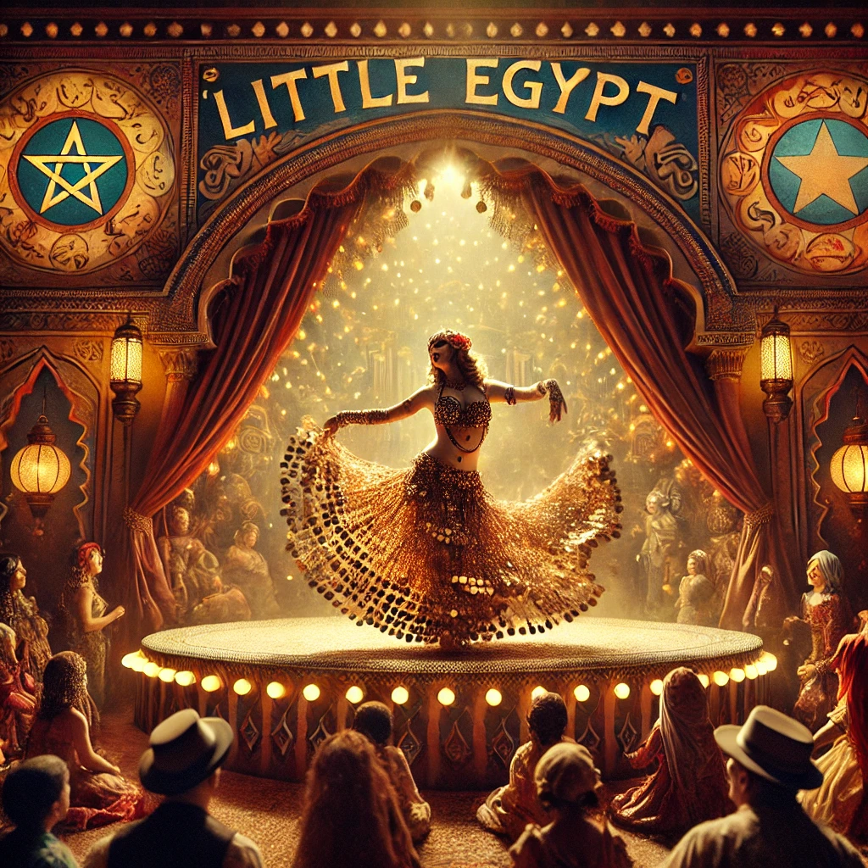

Show Tent

You are inside the Little Egypt Show. The attraction's facade is to the east. There are folding chairs organized neatly in rows. The show should start soon.

>z

Time passes.

In the dimly lit tent, you see that the stage is decorated to resemble an exotic Middle Eastern market or palace, featuring rich, colorful fabrics, brass ornaments, and lanterns casting a warm, flickering glow. Scents of incense waft through the air, enhancing the atmosphere of mystique. The backdrop displays painted scenes of pyramids, desert landscapes, and domed structures evoking a sense of being transported to the "Middle East".

>z

Time passes.

Little Egypt emerges draped in flowing silk veils which she skillfully uses as part of the dance. Her attire consists of a sparkling, sequined bodice and a flowing skirt, adorned with jingling coin belts and jewelry that accentuate her movements.

>z

Time passes.

The performance begins with slow, undulating movements, drawing you into the rhythm of exotic live music played on traditional instruments like the oud, darbuka, or zurna. As the tempo builds, her hips, torso, and hands move in intricate, mesmerizing patterns, demonstrating remarkable control and fluidity. She incorporates dramatic spins, drops, and shimmies, often accentuating the beat of the music with a quick jingle of her coin belt.

>z

Time passes.

Little Egypt makes eye contact with you and smiles enigmatically. During her performance she balances a sword on her head and accents her dance with finger cymbals.

>z

Time passes.

The music alternates between hauntingly slow melodies and rapid, energetic drum beats, creating an emotional arc that keeps you entranced. Little Egypt relies on the music's dynamic changes to tell a story with movements reflecting joy, sorrow, seduction, and celebration.

>z

Time passes.

The performance concludes with a dramatic flourish of a fast-paced shimmy, a bold spin, and Little Egypt dramatically casts off her veils. The dancer takes a bow to enthusiastic applause, leaving you spellbound by the sensual yet artful display.

You applaud until your hands are sore. Did she just wink at you?

As she leaves the stage, Little Egypt tosses one of her veils to you!

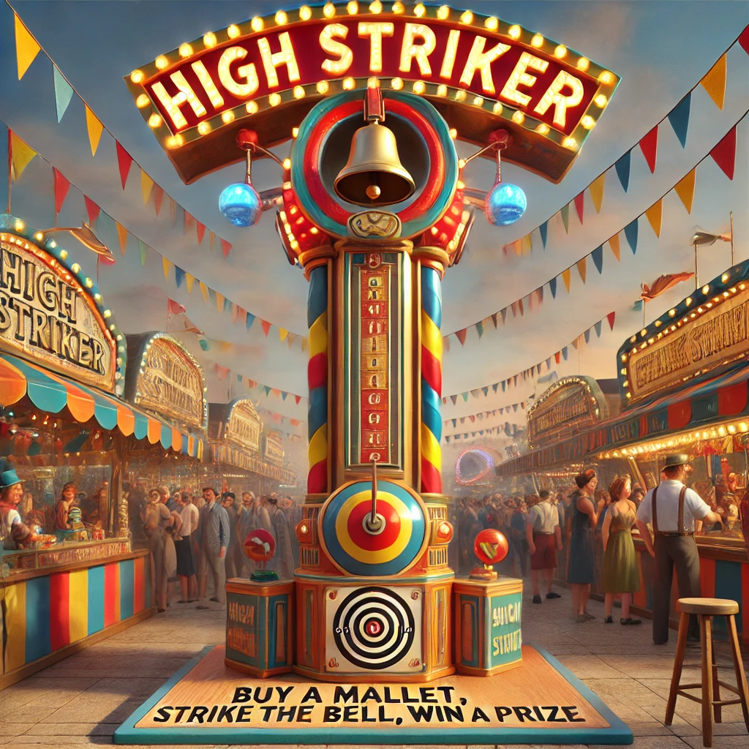

High Striker

This area features a tall, eye-catching machine adorned with bright, colorful lights, typically red, yellow, and blue. A large sign at the top reads "Test Your Strength!" in bold, playful lettering. The machine's base is made of polished wood, giving it a vintage appearance. At the center is a sturdy metal pole, with a large bell hanging at the top, signaling when a successful attempt has been made. Along the length of the pole are markings indicating how strong you are. A nearby sign says, "Buy a mallet, strike the bell, win a prize."

Spectators gather around, cheering on participants and offering lighthearted jabs and encouragement, creating a lively, competitive atmosphere. The sound of the mallet hitting the target is followed by the resonant clang of the bell (if struck), alongside the buzz of carnival music in the background.

The Ticket Kiosk is to the west. Other games are northeast and southeast of here. The Ferris Wheel lies to the east.

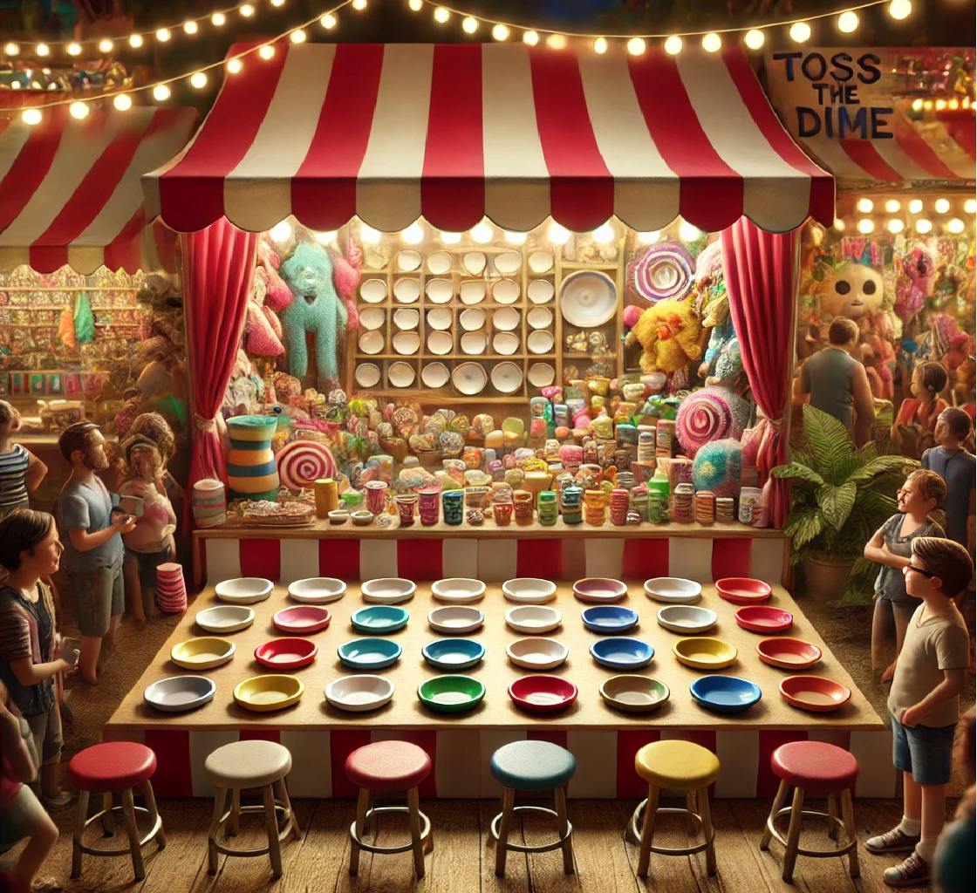

Dime Toss Game

The game booth is adorned with vibrant colors - red-and-white striped awnings, twinkling lights, and eye-catching signage that reads "TOSS A DIME - WIN A PRIZE!". You can see prizes of all shapes and sizes hang around the booth, from stuffed animals and novelty toys to shiny trinkets and quirky collectibles. The larger prizes are prominently displayed to entice passersby. Rows of gleaming plates sparkle under overhead lights, their glass surfaces reflecting the surrounding glow.

The distinctive "ping" of dimes hitting plates creates a rhythmic soundtrack, punctuated by the occasional satisfying "plop" when a dime lands perfectly. Victorious shouts mix with playful groans of near-misses, creating a symphony of excitement. Nearby, the hum of other booths, upbeat carnival music, and the distant laughter of children add to the lively backdrop. The booth operator calls out enthusiastically, "Step right up! Test your skill! Win big!" Their energetic pitch draws in curious onlookers. You thought you caught a flash of something coming from the area of the booth.

You're surprised to see that this game only costs a dime. The exit is to the southwest.

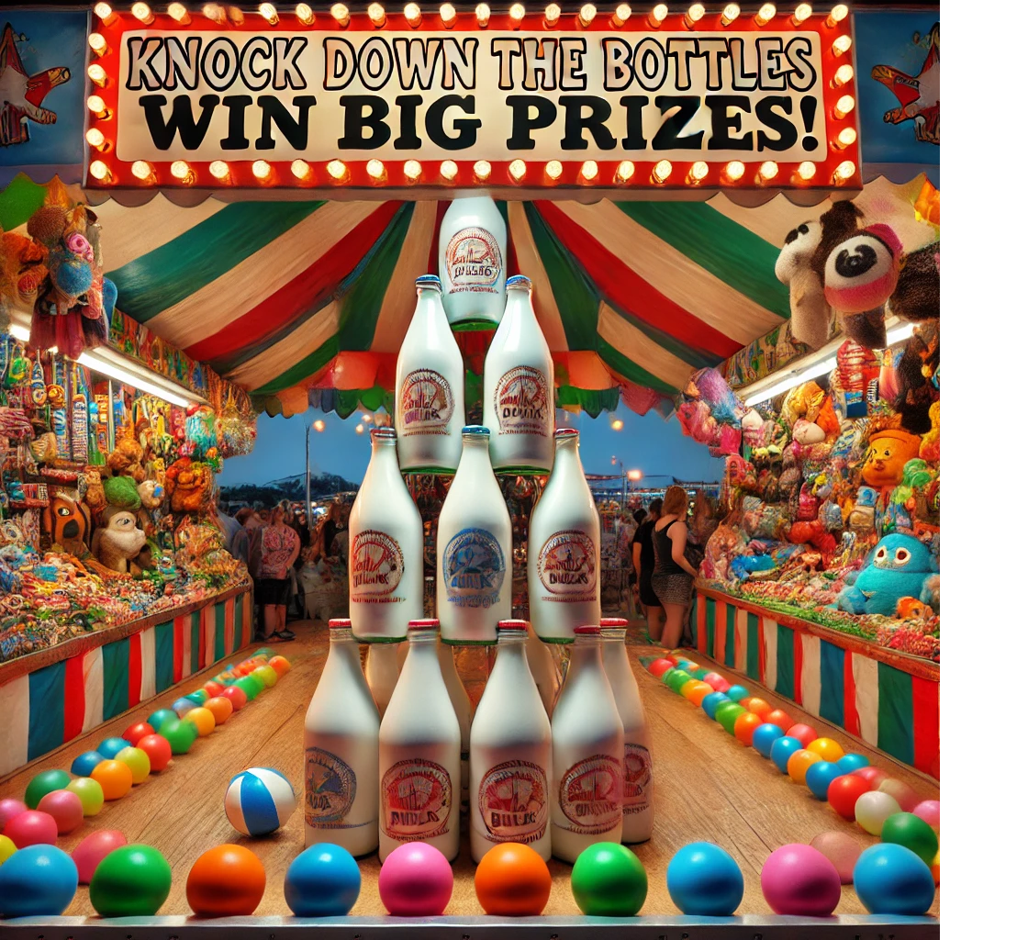

Pitcher's Mound

The milk bottle ball toss is a classic carnival game that combines skill, strength, and a bit of luck. The setup features a pyramid of brightly colored milk bottles stacked on a sturdy platform - three on the bottom, two in the middle, and one on top. Players stand behind a marked line and toss baseballs, aiming to knock down as many bottles as possible. Clearing the entire stack wins a prize.

The booth buzzes with energy, its colorful banners and flashing lights drawing a lively crowd. The satisfying clatter of falling bottles mixes with cheers and groans from players and spectators. A carnival attendant calls out, "Step right up and test your aim! Three balls for just a dime." Prizes - ranging from small toys to giant stuffed animals - hang prominently, enticing players to take a shot. With every toss, the game delivers moments of suspense, joy, and fun, making it a favorite at the carnival.

You're surprised to see that this game only costs a dime. The High Striker is to the northwest.

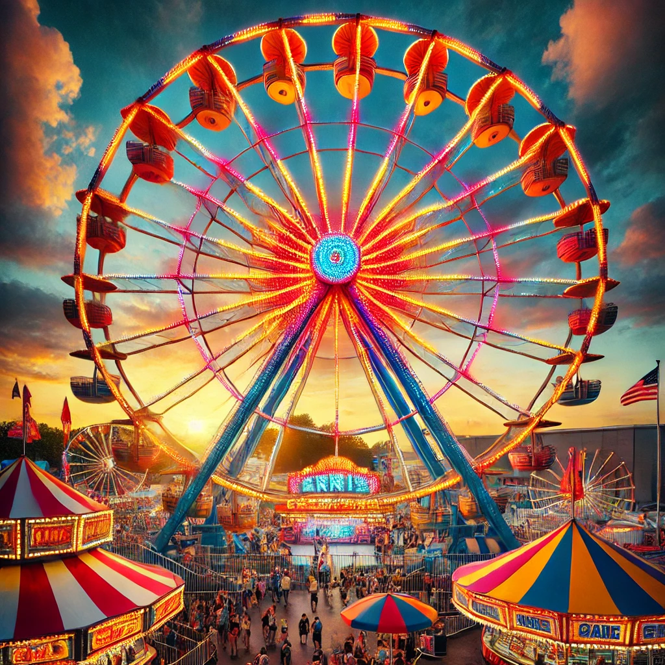

Ferris Wheel

The Ferris wheel is the towering centerpiece of the carnival, its vibrant lights and graceful rotations drawing the attention of visitors from every corner of the fairgrounds. The wheel's massive steel frame arches high into the sky, its intricate network of beams glinting under the colorful glow of bulbs strung along its circumference. Each gondola, painted in bright hues like red, yellow, and blue, dangles from the wheel, swaying gently as it turns.

At night, the Ferris wheel transforms into a dazzling spectacle, with hundreds of synchronized lights creating patterns and ripples that pulse outward like waves. The bulbs flash in bursts of red, green, and white, casting playful reflections on nearby attractions and the surrounding crowd.

The air around the wheel is filled with a mix of excited chatter, the hum of its motor, and the occasional squeal of laughter or nervousness from riders high above. The ride operator, standing in a small booth at the base, keeps a steady rhythm of loading and unloading passengers, their voice occasionally calling out, "Step right up! The best view of the carnival awaits!"

The Ferris wheel offers an ever-changing perspective of the carnival below. From its peak, riders can see the entire fairground: the spinning lights of the rides, the colorful stripes of game booths, and the winding paths of visitors navigating the midway. Beyond the carnival, the view stretches to the horizon, with city lights adding to the magical experience.

Whether it's a romantic ride for couples, a thrilling adventure for friends, or a calming retreat for families, the Ferris wheel captures the spirit of the carnival - an iconic blend of excitement, wonder, and timeless charm.

>give ferris wheel ticket to attendant

You give the Ferris Wheel ticket to the Ferris Wheel Attendant.

As you step into the gently swaying gondola, a faint creak accompanies the safety bar locking into place. The Ferris wheel begins its slow ascent, the hum of its machinery blending with the distant sounds of carnival games and laughter below. A soft breeze brushes against your face as the gondola rises higher, offering an ever-expanding view of the fairgrounds.

With each rotation, the world transforms. At the peak, the carnival sprawls beneath you like a miniature village, its vibrant lights twinkling against the twilight sky. The sound of the midway fades into a soft murmur, replaced by the serene quiet of being high above the bustling crowd. Beyond the carnival, the horizon stretches endlessly, framed by the glow of distant city lights.

The gondola sways gently, adding a hint of thrill to the tranquil ride. You exchange smiles with your companions, pointing out tiny figures darting between booths and the dizzying motion of other rides below. The Ferris wheel begins its descent, and the lively carnival sounds grow louder once again, bringing you back into the heart of the action.

Whether you're seeking a moment of calm, a romantic view, or the sheer wonder of seeing the world from above, the Ferris wheel delivers an unforgettable ride that captures the magic of the carnival.

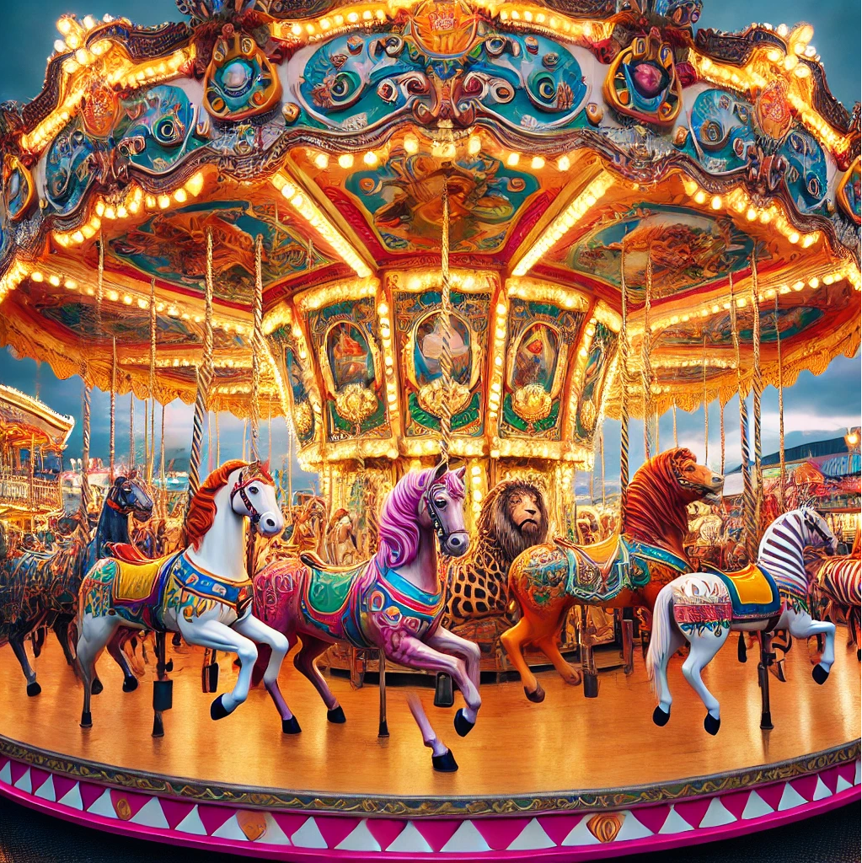

Carousel

The carousel is a timeless carnival attraction, radiating charm and nostalgia with its brightly painted horses, vibrant lights, and cheerful music. The circular platform is adorned with a canopy of swirling colors, gold trim, and decorative mirrors that reflect the flickering bulbs lining its edges.

Rows of hand-carved animals, most often horses with flowing manes, are arranged in a circle. Each is painted in vivid colors, detailed with golden saddles and ribbons. It also features exotic creatures like lions, tigers, and sea dragons, adding whimsy to the ride. The animals rise and fall gently as the carousel spins, mimicking a galloping motion.

The carousel's warm, playful tunes drift across the midway, inviting riders of all ages to enjoy its simple delight. Children laugh as they choose their favorite animals, while adults savor the nostalgia of the spinning ride. As it rotates, the carousel becomes a moving work of art, blending motion, color, and music into an enchanting centerpiece of the carnival. The Ticket Kiosk is back to the southwest; the way you came.

>give ticket

(the Carousel ticket to the Carousel Attendant)

You give the Carousel ticket to the Carousel Attendant.

Stepping onto the carousel's spinning platform, you're greeted by a kaleidoscope of color - brightly painted horses, glittering lights, and golden trim. The cheerful melody of calliope music fills the air. What will you choose as your mount, perhaps a galloping horse with a flowing mane, a majestic lion, or a whimsical giraffe. Gripping the polished pole, you settle onto the saddle, feeling the smooth rise and fall as the carousel begins to turn.

As the ride picks up speed, the world outside becomes a blur of glowing carnival lights and swirling colors. The gentle up-and-down motion mimics a playful gallop, and the rhythmic whir of the carousel's machinery adds a soothing backdrop to the cheerful atmosphere. Laughter and the sound of children's chatter mix with the music, creating a sense of nostalgia and joy.

For a few moments, you're transported into a magical world, the worries of the day fading away with each graceful rotation. Whether you're enjoying the ride alone, with friends, or sharing a special moment with family, the carousel's charm captures a timeless blend of whimsy and wonder. As it slows to a stop, you step off with a smile, the music lingering in your ears as you rejoin the bustling carnival.

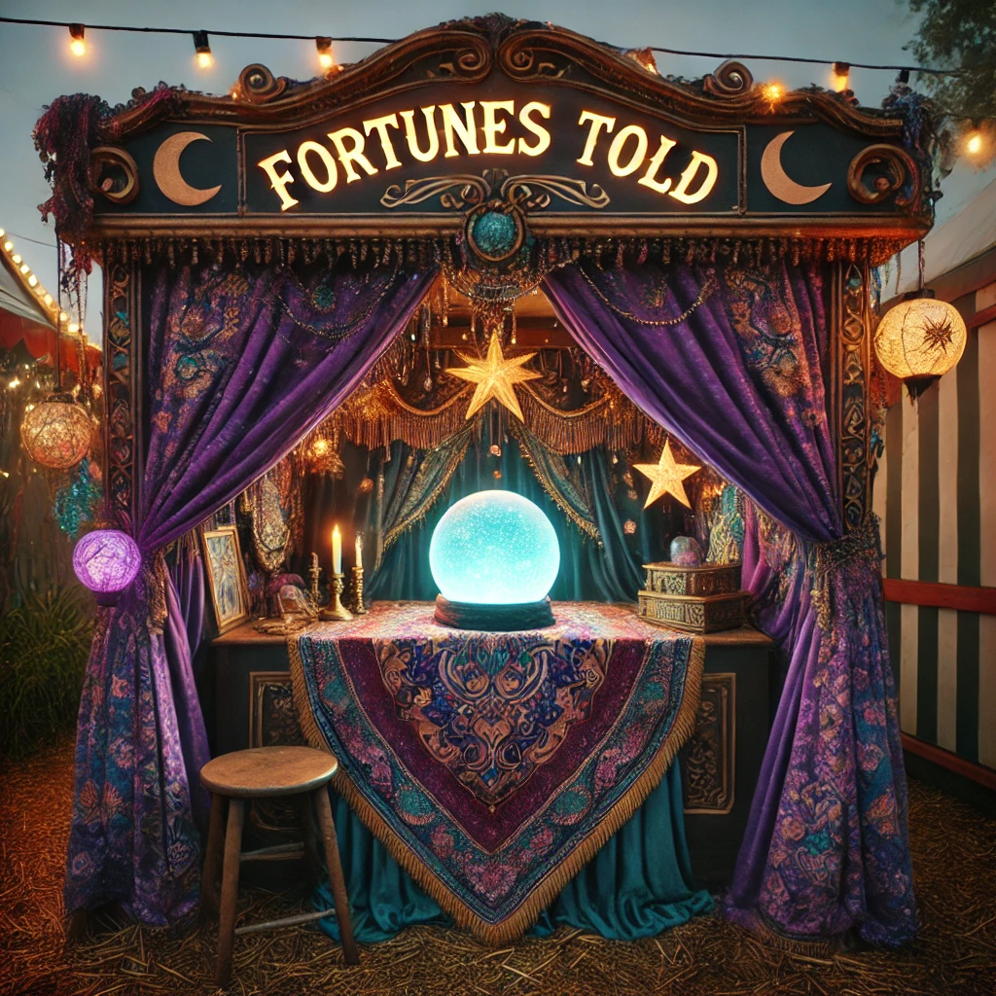

Fortune Teller

Approaching the fortune teller's booth, you're drawn in by its mysterious allure. Draped in deep purple curtains adorned with golden moons and stars, the booth glows with the soft, inviting light of candles. The air is heavy with the scent of incense, mingling with the sweet aroma of carnival treats. A sign sways slightly in the evening breeze.

You can see Esmerelda the Mysterious here.

>give ticket

(the Fortune Teller ticket to Esmerelda the Mysterious)

You give the Fortune Teller ticket to Esmerelda the Mysterious.

Stepping inside, you're greeted by the fortune teller, a figure cloaked in flowing robes with a jeweled headpiece catching the flickering light. Their piercing eyes seem to look right through you as they gesture for you to sit at a small round table covered in an ornate cloth. At its center rests a glowing crystal ball, surrounded by tarot cards and mysterious trinkets.

Esmerelda's voice is low and melodic, weaving an air of intrigue as they ask you to focus on a question and offer your palm for a reading. The room seems to shrink, the bustling carnival outside fading into the background as they reveal your fate. Each card turned and line traced on your palm feels significant, as though unlocking a secret you didn't know you carried.

As the reading concludes, the Esmerelda gazes into your eyes with a cryptic smile and delivers their final words of wisdom: "You need fuses." Whether you leave with a sense of wonder, excitement, or unease, the encounter lingers with you - a touch of magic amid the carnival's chaos, as if you've glimpsed something beyond the ordinary.

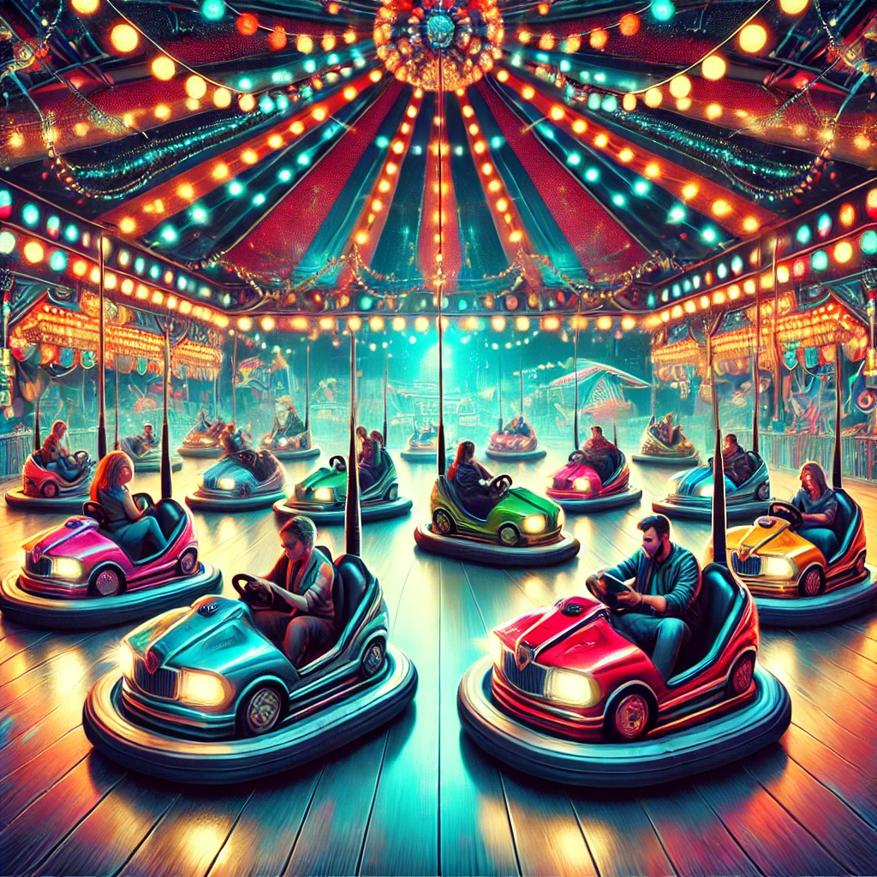

Bumper Cars

The bumper cars is a bustling hub of excitement and laughter, set beneath a canopy of flashing lights and colorful decorations. The rectangular arena is surrounded by padded barriers, ensuring a safe yet thrilling experience for riders. The floor, slick and metallic, allows the brightly colored cars - painted in shades of red, blue, yellow, and green - to glide effortlessly in all directions.

Each car is equipped with a steering wheel and a padded bumper, designed to absorb the impact of playful collisions. As the ride begins, drivers of all ages eagerly maneuver their cars, aiming for friends, family, or strangers with mischievous grins. The air is filled with the sound of bumpers colliding, laughter, and the occasional squeal of surprise.

Overhead, a web of electric poles connects the cars to the ceiling, sparking faintly as they supply power to the vehicles. The ride operator watches from a booth, ensuring everyone enjoys the chaos safely. Surrounding the bumper cars are cheering onlookers, carnival lights, and the lively hum of the fairground.

The bumper cars perfectly captures the playful spirit of the carnival, offering a mix of harmless competition, shared laughter, and nostalgic fun for all ages. The Ticket Kiosk is southeast of here.

>give ticket

(the Bumper Cars ticket to the Bumper Cars Attendant)

You give the Bumper Cars ticket to the Bumper Cars Attendant.

Sliding into the snug seat of the bumper car, your hands grip the steering wheel, anticipation buzzing in the air. Around you, the arena is alive with flashing lights, bursts of laughter, and the hum of electric currents running through the overhead poles. A quick glance shows other riders locking eyes, playful grins spreading as everyone braces for the chaos about to unfold.

As the ride starts, your car jolts forward, and you steer into the fray. The slick metal floor beneath makes every turn feel smooth yet unpredictable. Suddenly, bam! - another car collides into you from the side, sending your car into a spin. You laugh, recovering quickly to aim your vehicle at a friend across the arena.

The thrill of the bumper cars is in the collisions - every thud and jolt accompanied by squeals of delight or mock indignation. The impact is cushioned by the padded bumpers, keeping the fun safe but exhilarating. You swerve, dodge, and sometimes reverse in a desperate attempt to avoid being cornered, all while plotting your next playful crash.

The ride is a whirlwind of laughter, harmless competition, and shared joy. As the music fades and the cars slow to a stop, you climb out with a wide grin, already looking forward to your next turn in the driver's seat.

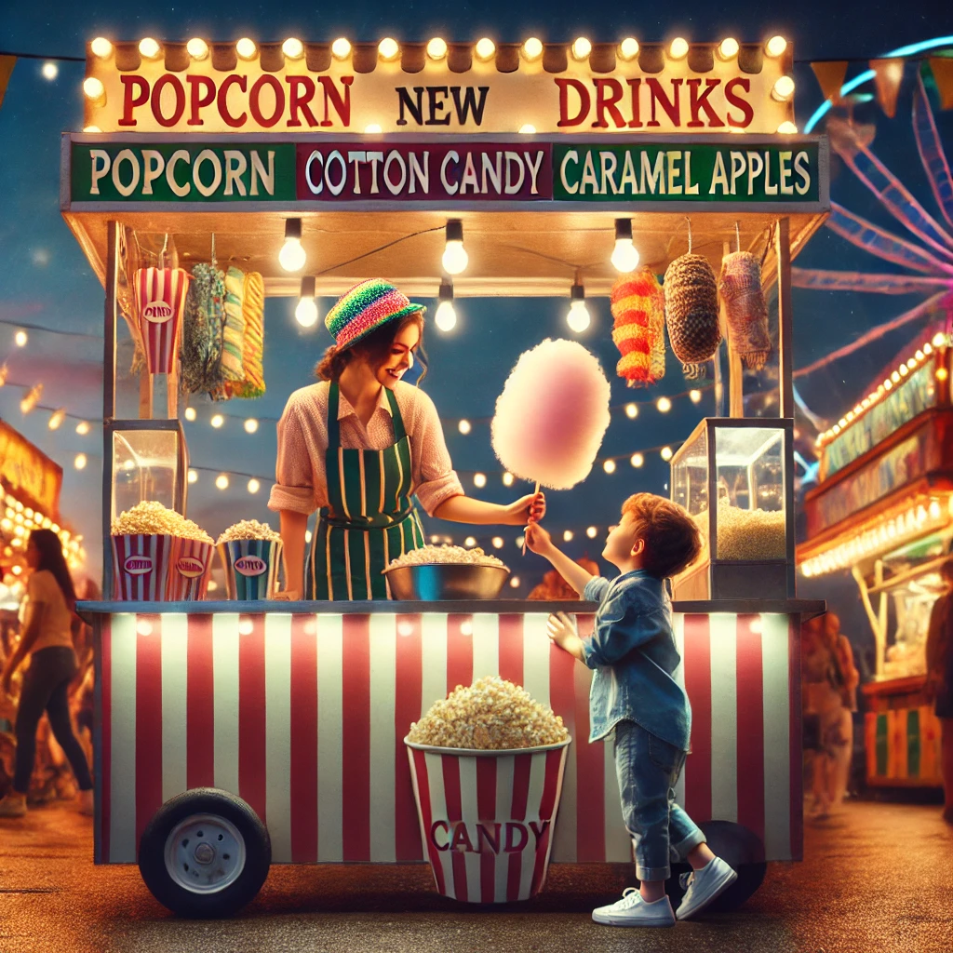

Concession Stand

The concession stand, perched along the midway, is a colorful and bustling hub. Painted in bright reds, blues, and yellows, it features bold lettering announcing treats like "SODA! POPCORN! CANDY APPLES!" Strings of twinkling lights frame the stand, making it a glowing beacon amid the carnival excitement.

Behind the counter, a popcorn machine churns out golden kernels, filling the air with a buttery aroma. Candy apples gleam under the lights, and cotton candy machines spin fluffy clouds of pink and blue. Warm pretzels sit under a heat lamp, their buttery, salted scent mingling with the sugary treats. A cooler holds sodas, their colorful labels visible through the frosted glass.

The counter is lively with stacks of paper bags, napkins, and cups of cheese and sugar sprinkles. A handwritten chalkboard menu lists prices in playful lettering. Workers in colorful aprons quickly hand out snacks, their movements efficient amid the cheerful chaos.

In front of the stand, kids tug at their parents, teens share pretzels, and the crowd buzzes with energy. More than just a snack stop, the stand is a sensory delight, adding flavor and charm to the carnival experience.

There is a menu to the right of the window. You can see the treats inside the stand. There is an exit to the northeast.

You can see a Concession Attendant, a menu, a Drink of Cola, some Bubblegum, a Bucket of Popcorn, a Candy Apple, Cotton Candy, and a Soft Pretzel here.

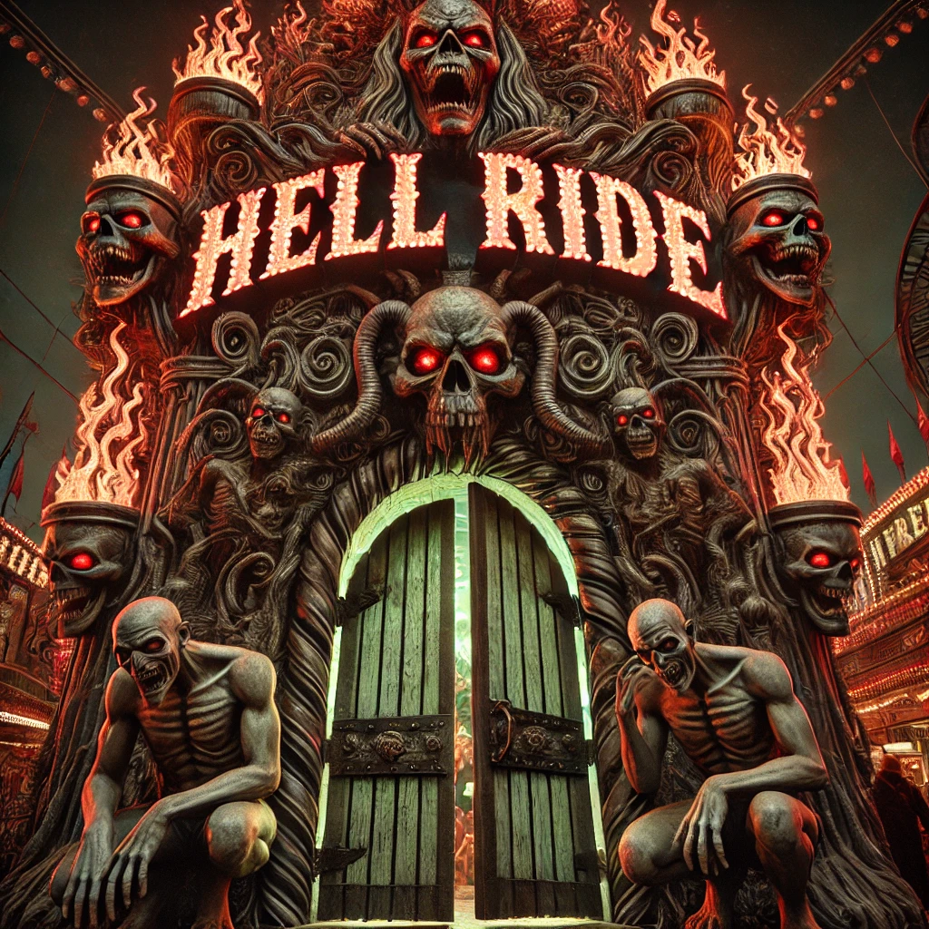

Ride Entrance

The cars that will take you into the fearsome Hell Ride stop here for you to board and then move forward, the safety bar locked in place, as the entrance to Hell Ride looms ahead - a grotesque facade of twisted metal and carved wood, illuminated by flickering blood-red lights. The air carries a faint sulfuric tang mingled with the sweet aroma of carnival popcorn.

A towering archway of flames, spikes, and grinning skulls frames the entrance, crowned by flickering letters that read "HELL RIDE", pulsing like a heartbeat. Below, crouching demon sculptures extend clawed hands in a sinister invitation. Wooden doors cover the entrance, whispering with faint, menacing chuckles as distorted organ music grows louder, punctuated by shrieks and grinding machinery.

Inside, near-total darkness is broken by flashes of sickly green light revealing twisted paths and grotesque shapes. Beyond the threshold lies only uncertainty and terror. To one side, the darkness looks a little bit darker than the rest of the room.

You can see a Hell Ride car (empty) here.

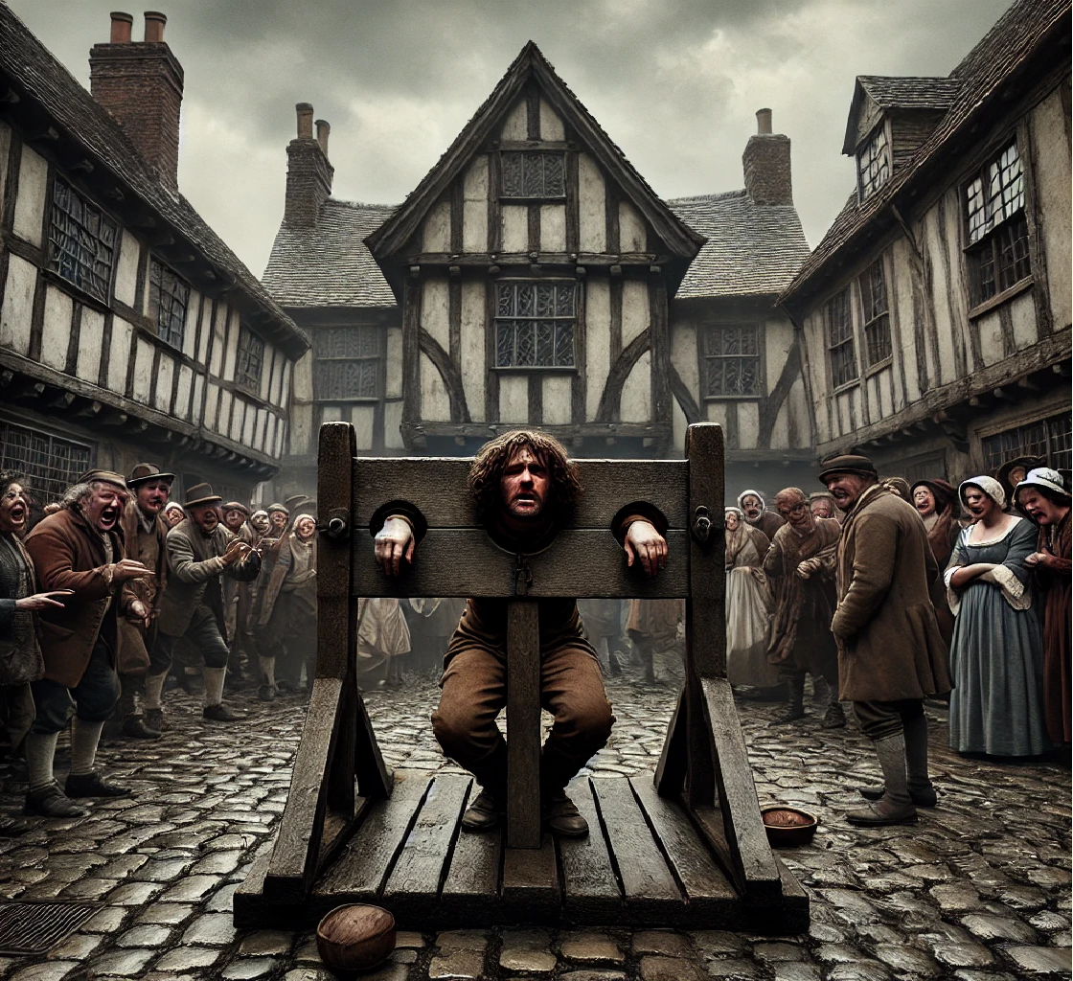

Stocks Room (in the Hell Ride car)

The public square is a cobblestone expanse bordered by weathered timber-framed buildings. The air carries the mingling scents of chimney smoke, damp earth, and the faint tang of a nearby smithy. At its center, crude wooden stocks stand as a grim focal point, their beams weathered and stained from years of use. Iron clasps lock captives in degrading postures, their tattered clothing offering little protection from the biting wind.

The animatronics and wax figures are extremely life like. Hell Ride sure lives up to its name.

The punished individuals hang their heads in shame, their faces etched with despair. Around them, the crowd revels in cruelty - a wiry man spits insults with gleeful laughter, while a stout woman throws overripe vegetables, each impact sparking jeers. Even children join in, pointing and mocking with mischievous delight.

The square hums with noise: the crowd's taunts, the crack of objects hitting wood, and the quiet murmurs of the suffering captives. Overhead, a gray sky threatens rain, indifferent to the spectacle below. The jeering mob ignores its ominous weight, too engrossed in their shared cruelty to notice nature's disapproval.

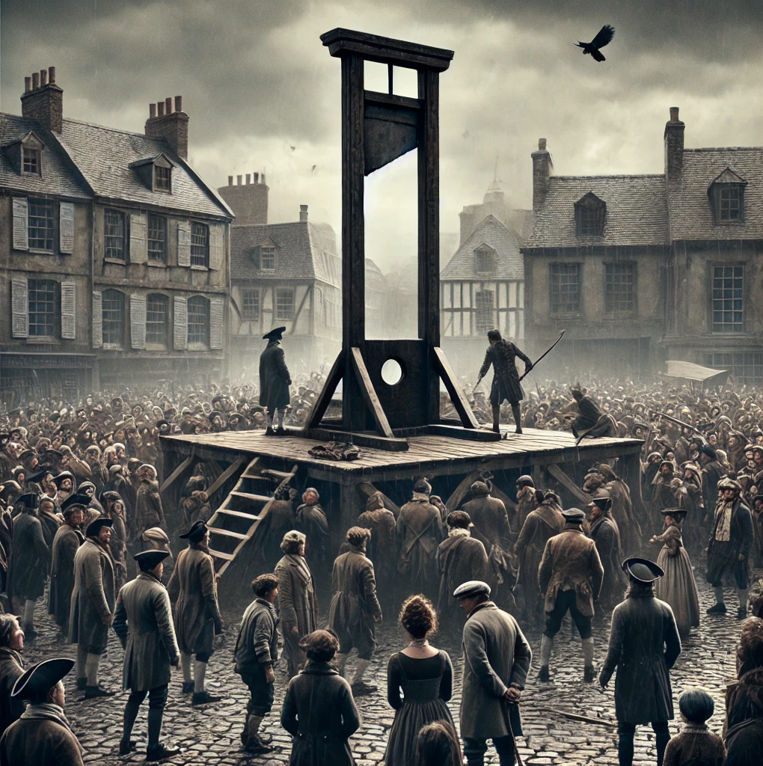

Gallows Room (in the Hell Ride car)

The public square, slick with morning drizzle, lies under a brooding, overcast sky. At its center looms the gallows, a weathered wooden platform with thick ropes swaying ominously. The crowd stands in somber silence, broken by the shuffle of feet or faint murmurs, their eyes fixed on the grim scene.

A hooded executioner, cloaked in black, adjusts the frayed noose with practiced precision, his cold presence exuding purpose. In front of him stands the condemned man, pale and trembling, his bound hands behind him. Beads of sweat mix with rain on his haunted face as his darting eyes search the indifferent crowd. Each shallow breath forms a fleeting cloud in the chilly air - a fragile reminder of his fleeting life.

Vendors hawk bread and cider, while children strain for a better view. An old man clutches a rosary, whispering prayers, as others smirk and place bets. Above, the bell tower tolls, its mournful chime marking the passage of the man's final moments. A raven perches on the gallows" beam, its unblinking gaze fixed on the scene below.

As the executioner adjusts the noose around the man's neck, the crowd falls silent, the air thick with dread. Distant thunder rumbles faintly, as if the heavens themselves await the inevitable.

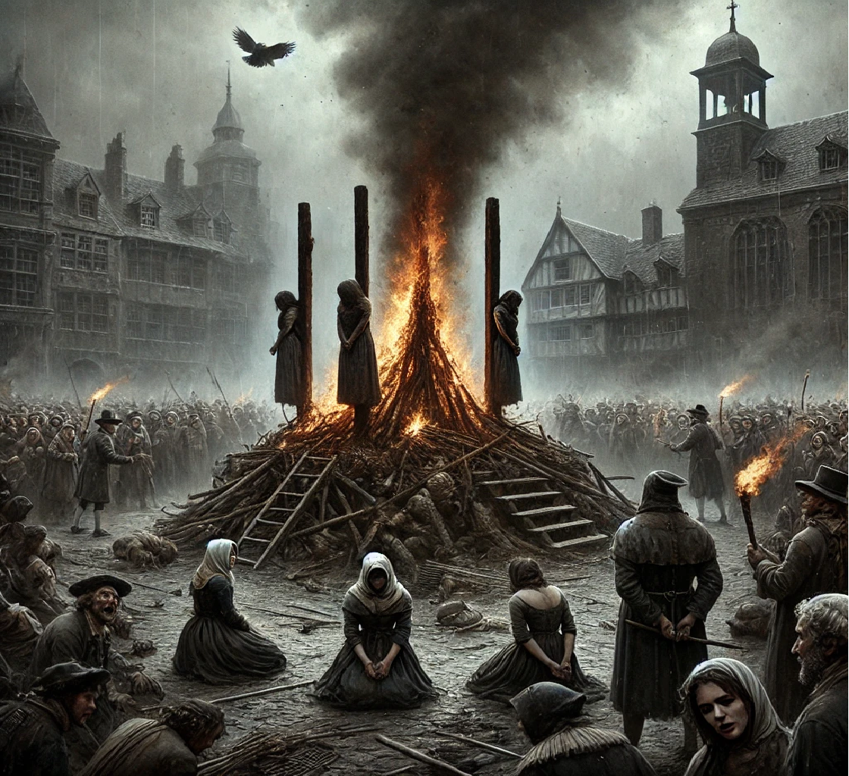

Stake Room (in the Hell Ride car)

The public square is steeped in grim silence, broken only by the crackling of flames. At its center, three wooden stakes rise from a pyre of logs and kindling, darkened by smoke from past executions. Bound to the stakes are three women, their faces reflecting defiance, resignation, and terror.

A crowd encircles the scene, expressions ranging from morbid fascination to righteous fury. Children cling to their mothers, while elders nod solemnly. Some jeer and throw stones; others murmur prayers or avert their gaze.

The executioner, hooded and clad in a leather apron, steps forward with a blazing torch, igniting the pyre in a sudden roar. Flames climb rapidly as thick smoke coils upward. The condemned cry out, their voices mingling with the crackle of fire. The oppressive heat radiates outward, pressing against the silent, uneasy crowd.

Gray clouds loom overhead, nature's somber backdrop to the grim spectacle. A raven caws from the bell tower as slow church bells toll, each strike punctuating the tragedy. As the pyre burns, some onlookers remain transfixed while others quietly slip away, the square heavy with ash, smoke, and the echoes of the condemned.

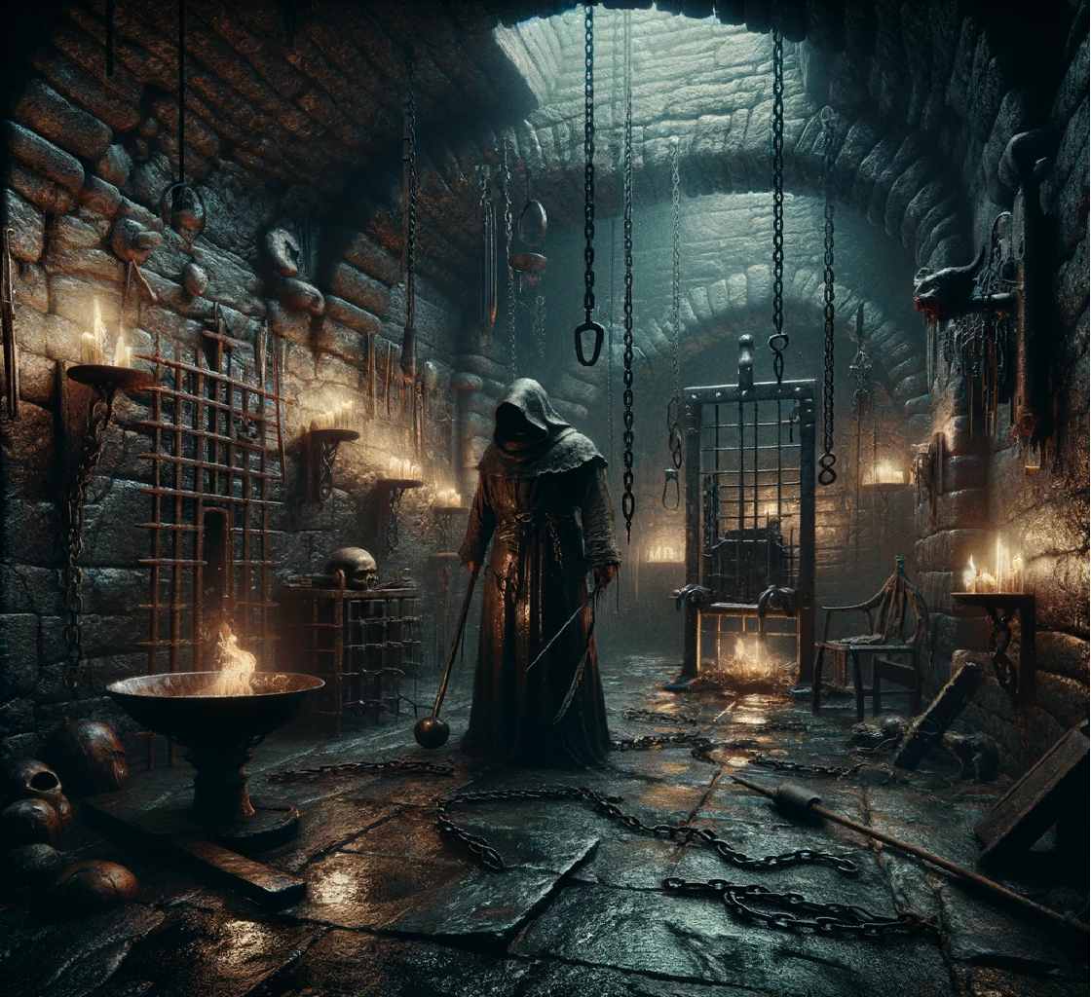

Dungeon (in the Hell Ride car)

The dungeon is a dark, suffocating chamber carved into the earth, its stone walls slick with moisture and grime. The air reeks of sweat, blood, mildew, and burning oil from flickering torches mounted on rusted sconces. Shadows twist on the walls, creating grotesque, unsettling shapes in the dim light.

Chains hang from walls and ceilings, their faint clinking blending with the moans and occasional screams of prisoners. Water drips rhythmically from a cracked ceiling, adding to the chamber's eerie ambiance.

The room is littered with instruments of torment: a splintered rack, a glowing brazier holding bloodstained tools, and a spiked chair gleaming faintly in the light. Prisoners endure their own horrors - one stretched on the rack, another hanging limply from manacles, and a third gasping weakly in the spiked chair.

The hooded torturer moves with detached precision, their leather apron stained with the evidence of countless victims. They work silently, indifferent to the agony surrounding them.

Above, rats scuttle in the shadows, and the low ceiling presses down like the weight of despair. This is a realm of suffering and hopelessness, where life and death blur, and torment is the only certainty.



Guillotine Room (in the Hell Ride car)

The public square buzzes with tense anticipation, a crowd gathered under gray skies that cast a somber light on the cobblestones. At the center, a stark wooden platform looms, its purpose grim and unavoidable.

A lone figure stands on the scaffold, bound hands behind their back and head bowed low, avoiding the crowd's gaze. Their tattered clothing, once fine, reflects the fall that led them to this moment.

The crowd encircles the platform, emotions ranging from jeers and curses to silent, grim observation. Children sit on shoulders, their curious eyes unaware of the event's gravity. Near the edge of the platform, the town crier proclaims the crime: "High treason against the crown. Let this be a warning to all who defy the realm!"

The condemned flinches but remains silent as the executioner - a hooded figure in black - stands ready beside the guillotine, its blade gleaming faintly in the dim light. The murmurs of the crowd fall into silence at the executioner's signal, leaving only the rustle of wind and the creak of the scaffold.

As the condemned approaches the guillotine, a crow caws sharply from a nearby rooftop, its cry echoing through the square like an omen. The crowd leans forward, breath held, as justice and mortality converge on the scene.

There is just one problem: the guillotine is being raised and lowered by some mechanism. It appears that the timing of the guillotine is off and it is being lowered onto the cars instead of between them. If a person were to be in a car as it passed under the guillotine, they would be decapitated.

Looks like your goose is cooked. Say "Goodnight, Gracie!"

You are stupefied as you sit watching guillotine rising and falling, dropping like a stone on the cars in front of you. Thank goodness they are empty. As your turn comes, you raise your hands in a feeble attempt to stop the inevitable.

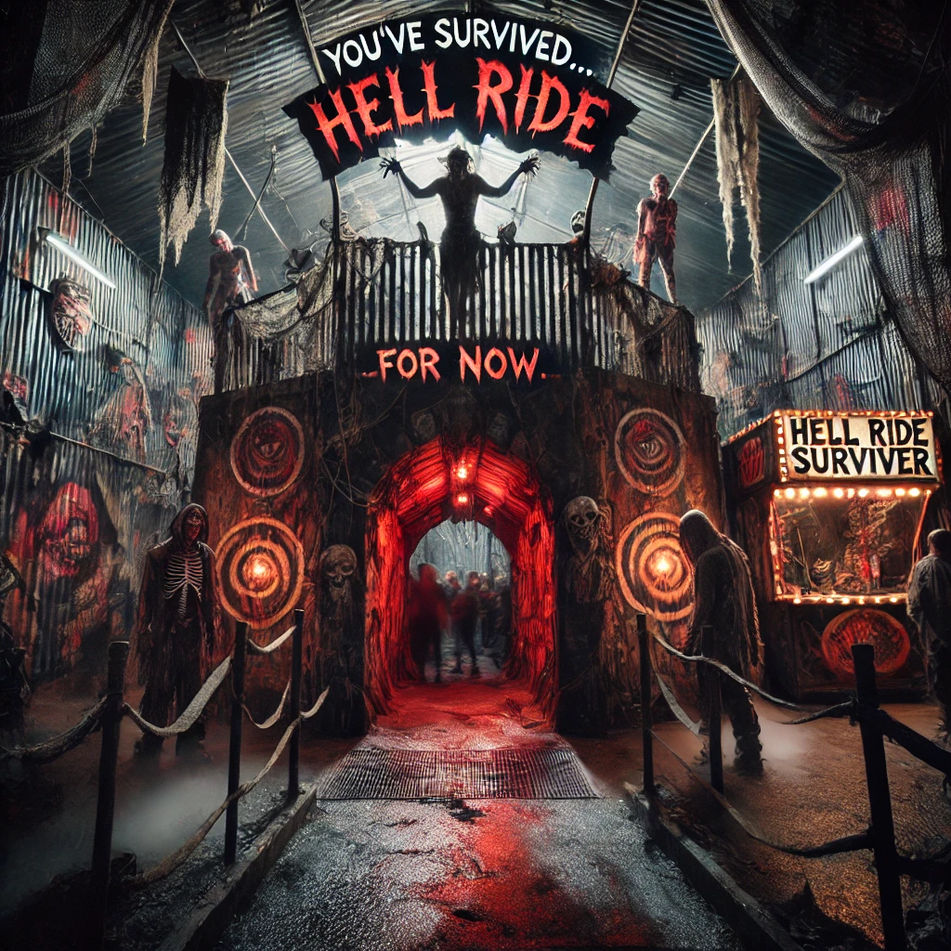

Ride Exit

The exit of Hell Ride is designed to leave riders with lingering unease. Emerging from a dark corridor with peeling black and red-streaked walls, flickering lights cast erratic shadows on the uneven floor. The air is cool and damp, carrying a faint metallic tang, while faint whispers and distant screams echo softly in the background.

Riders step into a small courtyard enclosed by jagged, rusted fencing draped with cobwebs and plastic bones. Overhead, a weathered sign reads, "You've Survived? For Now." Nearby, carnival workers in tattered costumes watch silently, occasionally muttering cryptic remarks like, "Not everyone makes it out."

A merchandise display glows red, selling items like Hell Ride Survivor t-shirts and key chains. Beyond the fencing, the cheerful carnival lights and sounds feel jarring, contrasting sharply with the ride's oppressive atmosphere.

The exit ensures Hell Ride isn't just an experience - it lingers, blurring the line between thrill and fear.

There is a price list next to the cash register. An attendant is here to assist you with your purchases. The stand has an Aqua colored fuse, Plastic Bones, Devil Horns, Key Chains, and T-Shirts for sale.

Control Room

The backstage control room is a plain, functional hub where the carnival's rides, lights, and attractions are managed. Gray industrial walls, scuffed and greasy, surround a large monitor streaming live carnival feeds. Beneath them, control panels with labeled dials, colored buttons, and lights oversee the systems scattered about the room. Glancing at the control panels, you can see they are dark.

The hum of electronics fills the air, punctuated by the crackle of a radio: "Maintenance to Bumper Cars - wrench needed!" The worn floor is scattered with papers, tools, and coffee cups. A cluttered desk holds logs and schedules, while a cork board above displays charts and red-marked notes like "Check Zipper circuit breakers."

A flickering light casts cold shadows as the metallic tang of machinery mixes with dampness. Functional yet essential, this hidden space ensures the carnival's magic runs seamlessly. On one wall is a large switch with sparks arcing out from it.

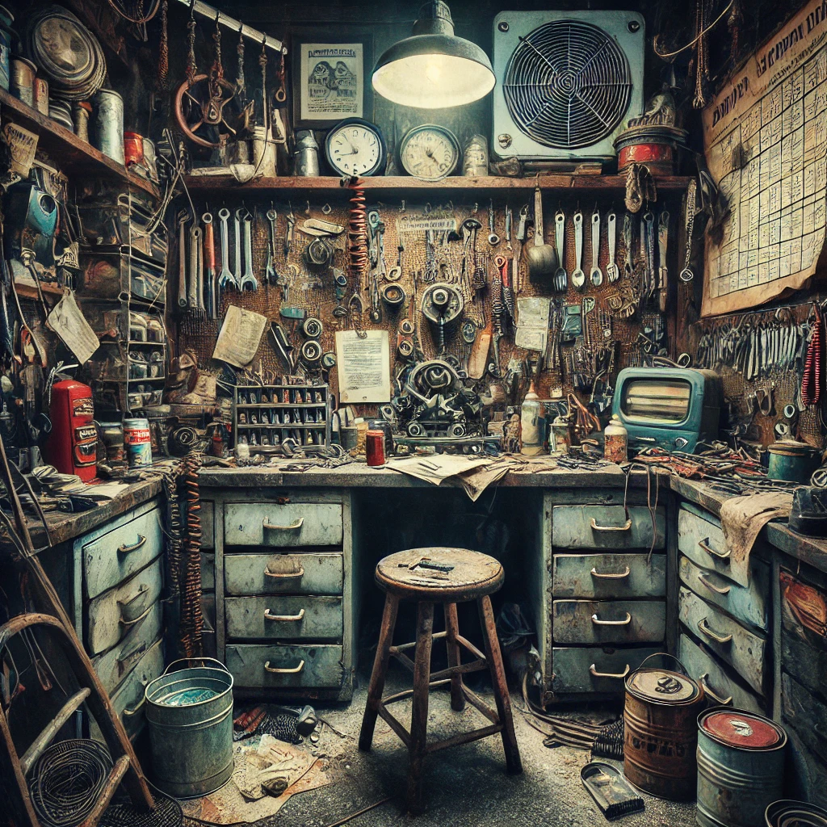

Maintenance Office

The maintenance office, hidden behind the carnival's bright facade, is a dim and cluttered space reeking of grease, sweat, and faint traces of popcorn from the midway. The air hangs heavy with oil and stirred-up dust.

The walls are lined with shelves holding tools and parts in disarray - screws and mismatched containers with faded labels. Paint cans and grease jars clutter the workbenches, many left half-open. In the center, a battered desk is strewn with wires, gears, and springs, a bent piece of metal held in a vise. Overhead, a single flickering fluorescent light struggles to illuminate the room.

In one corner, a disassembled ride mechanism lies exposed, chains and pulleys dangling from hooks above, faintly clinking with the vibrations of the rides. A grease-stained manual and a half-drained mug of coffee sit abandoned on a nearby stool.

The walls display faded safety posters, a cork board with maintenance schedules and notes, and a worn photo of the carnival in its prime. A clock ticks faintly, its hands out of sync with reality. The floor, gritty with dust and scattered nails, adds to the room's chaotic charm.

Despite the mess, the room buzzes with purpose - a hidden hub where the carnival's magic is sustained through sweat, ingenuity, and the hum of machinery.

Crawl Space

The crawl space beneath the carnival ride is a tight, claustrophobic tunnel shrouded in darkness and filled with the hum of machinery above. The air is stale and heavy, carrying the sharp metallic scent of oil and the faint tang of rust. Every sound is amplified in the confined space - the groaning of steel beams, the clanking of chains, and the rhythmic thrum of motors driving the ride above.

The ground is uneven, a mix of packed dirt and loose gravel scattered with forgotten tools, scraps of metal, and tangled wires. Overhead, a network of pipes crisscross the space, some wrapped in fraying insulation that crackles faintly as you crawl past. Small puddles of murky water collect in dips on the floor, their surfaces rippling with vibrations from the ride's movement.

Mechanical Room North

The north mechanical room is compact and specialized, housing auxiliary systems that keep the ride running smoothly. A subdued hum of capacitors and relays fills the space, its quiet rhythm broken only by the occasional hiss of hydraulic fluid.

Circuit breaker panels line the walls, labeled for functions like "Lighting Controls" and "Brake Systems". Smaller cables and conduits snake along the walls, linking these systems to the main hub. In one corner, a hydraulic pump and reservoir manage lifting arms and rotating platforms, their gauges flickering as they work.

A small workbench against the eastern wall is cluttered with tools and coiled wires, while shelves above hold neatly labeled spare parts - cables, and hydraulic tubing. A faded ride diagram pinned nearby is marked with red annotations from past repairs.

Dimly lit by a single hanging bulb, the room feels cooler and slightly damp, the metallic tang of machinery mixing with a hint of mildew. Though quieter and less prominent than the south mechanical room, this space plays a vital role in supporting the ride's operation and ensuring its emergency systems are always prepared.

Mechanical Room South

The south mechanical room is the operational core of the carnival ride, a bustling, noisy space dominated by a massive motor. Its steady hum drives the thick belts, pulleys, and gears that work in perfect unison to power the ride.

Heavy-duty electrical panels line the walls, adorned with warning labels like "High Voltage" and blinking indicator lights in an array of colors. Overhead, labeled conduits and wires snake across the ceiling, connecting systems with meticulous precision.

A cluttered table holds tools and spare parts - bolts and lubricants - alongside open maintenance logs marked with greasy fingerprints. The air is thick with the smell of oil, metal, and a faint trace of ozone from the electrics.

A cooling fan spins in the corner, barely cutting through the room's warmth. The hum of machinery is occasionally punctuated by clinking chains and the sharp hiss of hydraulic fluid. The floor, a mix of metal grates and worn concrete, reflects years of use and maintenance.

Bright fluorescent lights in wire cages illuminate the space, highlighting the intricate systems at work. The south mechanical room is the ride's powerhouse, where every movement is controlled with precision to deliver its thrilling experience.

Generator Room

The generator room is a compact, utilitarian space where the lifeblood of the carnival's power is produced. Its reinforced concrete walls bear grime, oil streaks, and faint graffiti from past workers. The air carries a mix of diesel, hot metal, ozone, and damp earth, creating a distinctly industrial scent.

At the center, the main generator hums steadily, its scuffed steel casing evidence of years of service. Thick rubberized cables extend from it like veins, connecting to junction boxes and circuit breakers along the walls. A large panel nearby is cluttered with buttons, switches, and gauges, many with faded labels like "Fuel Intake" and "Emergency Shutoff." A flickering display screen shows power levels and load distribution.

The rough concrete floor is uneven, marked by small puddles of spilled fuel or condensation. Shelves along the walls hold spare parts - filters, spark plugs, and wire coils - while a work area sits beside a grease canister and a worn maintenance manual.

A single industrial bulb in a protective cage casts harsh light, leaving deep shadows across the machinery. In the corner, a vent fan whirs faintly, struggling to cool the warm, vibrating air. A row of diesel canisters gleams beneath a faded safety sign that warns, "Fuel Safely - No Open Flames!"

Though isolated and utilitarian, the generator room is the carnival's heartbeat, powering its lights, rides, and sounds. Its quiet separation from the carnival's chaos serves as a stark reminder of the machinery driving the magic.

Electrical Room

The electrical room is a small but essential space hidden behind the carnival's bright attractions. The air vibrates with electric energy, carrying the acrid scent of overheated wires and metal. Metal panels line the walls, some polished, others worn and streaked with grease.

A central breaker panel, labeled with destinations like "Ferris Wheel Lights" and "Carousel Motors," dominates one wall. Colored indicator lights blink intermittently, reflecting off steel surfaces. Overhead, thick cable bundles snake across the ceiling, connecting to the carnival's power network.

In a corner, an open junction box spills wires onto the wall, while a workbench holds scattered tools and a smudged wiring diagram pinned above. The dirt floor bears scratches, oil stains, and wire clippings. A faint vibration, carried from the generator or nearby rides, pulses through the room.

An emergency shutdown panel painted bright red stands near a fire extinguisher and a faded safety poster. A small fan on the workbench oscillates weakly, barely cooling the room's warmth. Flickering fluorescent tubes overhead cast harsh, shifting shadows.

The electrical room is raw and utilitarian, revealing the fragile systems behind the carnival's magic - a humbling reminder of the power sustaining the midway's enchantment.

This room is eerily quiet, missing the ever present buzz of electricity. There are exits in all directions.

Storage Room

The carnival storage room is a cramped yet essential space, tucked away from the bustling grounds. Its rusted metal and peeling wooden walls bear the marks of years of use, while the air hangs heavy with grease, dust, damp canvas, and a faint trace of stale popcorn.

Shelves overflow with supplies - boxes of light bulbs, spools of wire, and assorted ride parts - piled without order. Tangled flags and strings of lights dangle from hooks, while crates labeled "GAME PRIZES" and "RIDE PARTS" hold items like stuffed animals and plastic toys. Folded tarps and tent poles teeter in one corner.

The room's center is dominated by larger objects: spare ride seats, unassembled booths, and faded attraction pieces like a scratched carousel horse, all hidden beneath protective tarps.

Near the entrance, a battered desk is cluttered with maintenance logs and empty coffee cups. Above it, a bulletin board brims with ride schedules and repair requests. A flickering fluorescent bulb casts uneven shadows, adding an eerie atmosphere.

The floor, a rough blend of concrete and dirt, is littered with nuts and wire scraps. In the dim corners, the scuttle of rats and the glint of cobwebs underline the room's gritty nature.

Chaotic yet indispensable, this hidden space powers the carnival's magic, ensuring every ride and booth runs seamlessly.